Why Spring data JPA:
It is quite cumbersome to implement data access layer now a day. You need to write too much boiler plate code to even execute simple queries and you have to write too much code before and after executing queries. Spring data JPA provides APIs which is quite abstract and you just need to write repository interface and Spring data JPA will provide implementation automatically.
For example, if we write some application in JPA, then we have to
- Write queries for accessing data. Queries could be in string format which are error prone.
- We have to manage connection i.e. persistence unit, entity manager and factories manually.
- Inserting, updating and deleting entities requires calls to entity manager which becomes repetitive.
Spring Data has the following sub-projects:
- Spring Data Commons
- Spring Data MongoDB
- Spring Data Redis
- Spring Data Solr
- Spring Data Gemfire
- Spring Data REST
- Spring Data Neo4j

Spring Data Interfaces:
- Repository:
Central repository marker interface. Captures the domain type to manage as well as the domain type’s id type. General purpose is to hold type information as well as being able to discover interfaces that extend this one during classpath scanning for easy Spring bean creation.
It is the central interface in the spring data repository abstraction. This is a marker interface. If you are extending this interface, you have to declare your own methods and the implementations will be provided by the spring run-time. For this interface also we have to pass two parameters:type of the entity and type of the entity’s id field. This is the super interface for CrudRepository.
public interface CustomerRepository extends Repository<Customer, Long>{
// no need to write anything here as Repository is marker interface
}
- CrudRepository :
Interface for generic CRUD operations on a repository for a specific type.
CrudRepository extends Repository and adds methods for finding, saving, inserting entities. It acts as abstraction.
CrudRepository provides methods for the CRUD operations. This interface extends the Repository interface. When you define CrudRepository, you have to pass the two parameters: type of the entity and type of the entity’s id field. This interface has the following methods:
- S save(S entity)
- T findOne(ID primaryKey)
- Iterable findAll()
- Long count()
- void delete(T entity)
- boolean exists(ID primaryKey)
If you are extending the CrudRepository, there is no need for implementing your own methods. Just extend this interface and leave it as blank. Required implementations are provide at run time.
public interface EmployeeRepository extends JpaRepository<Employee, Integer> {

}

PagingAndSortingRepository:
Extension of CrudRepository to provide additional methods to retrieve entities using the pagination and sorting abstraction.
PagingAndSortingRepository extends CrudRepository and adds functionality for sorting and paging results.
These three interfaces are part of spring data commons.jpa
JpaRepository vs CrudRepository :
Both, JpaRepository and CrudRepository are base interfaces in Spring Data. Application developer has to choose any of the base interfaces for your own repository. It has two purposes,
- One is to allow spring data to create proxy instance for your repository interface.
- Second one is to inherit the maximum default functionality from the base interfaces without declaring your own methods.
When we look at both of the interfaces, the clear differences are:
- CrudRepository is part of Spring Data Commons project and declared under the package org.springframework.data.repository. Where as JpaRepository is part of store specific implementation and declared under the package org.springframework.data.jpa.repository.
- CrudeRepository extnds from Repository interface. Where as JpaRepository extends from PagingAndSortingRepository which inturen extends from the CrudeRepository.
- JpaRepository returns List type of entities and CrudRepository returns Iterabletype of entities.
- It is general recommendation that not to use the store specific base interfaces as they expose the underlying persistence technology and tighten the coupling between them and the repository. It is always good idea to choose any of the generic base interfaces like CrudRepository or PagingAndSortungRepository.

The below diagram shows the repository module structure.

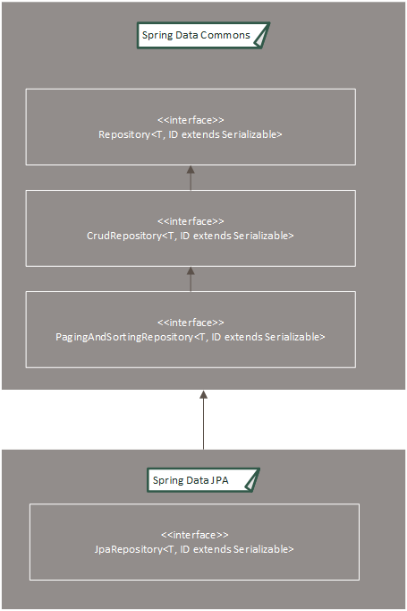

Query Methods:
- Query methods are used for finding the information from database and that are declared in the repository interface.
- Query methods can return one result or more than one result.
- This also supports passing parameter to database queries by sending through parameter binding or named parameters.
- If you want to implement query methods, implement Repository interface and write your own methods.
Here is a simple example of how to write query methods:
public interface BookOwnRepository extends Repository<Book,Long>{
List<Book> findByName(String name);
List<Book> findByPrice(long price);
List<Book> findByNameAndAuthor(String name, String author);
}
- Using query methods are most convenient way to write our own queries to fetch data from the database. Spring data jpa allows more powerful query formation using the methods names and parameter.
- In the above example class, we have used only a few naming conventions are forming the query.
  - findBy… – this is the prefix, anything follows this prefix will be used for framing the query
  - findByName – In this method, only the matching names are returned. Here we are pasing only one parameter name.
  - findByNameAndAuthor – In this method, we are using the “And” to add more information to the query by search either using name or author. In the similar way, you can use the “Or” delimiter.

Project Structure:
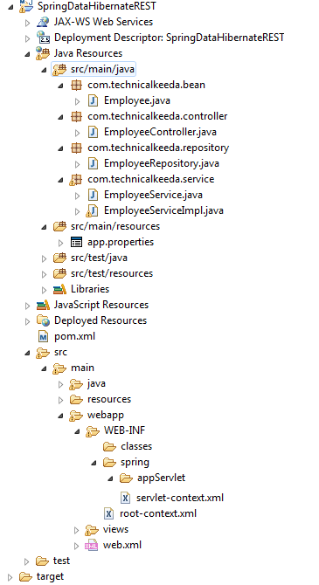

Web.xml:
<?xml version="1.0" encoding="UTF-8"?>
<web-app xmlns:xsi="http://www.w3.org/2001/XMLSchema-instance"
xmlns="http://java.sun.com/xml/ns/javaee"
xsi:schemaLocation="http://java.sun.com/xml/ns/javaee http://java.sun.com/xml/ns/javaee/web-app_2_5.xsd"
version="2.5">
<context-param>
<param-name>contextConfigLocation</param-name>
<param-value>/WEB-INF/spring/root-context.xml</param-value>
</context-param>
<listener>
<listener-class>org.springframework.web.context.ContextLoaderListener</listener-class>
</listener>
<servlet>
<servlet-name>appServlet</servlet-name>
<servlet-class>org.springframework.web.servlet.DispatcherServlet</servlet-class>
<init-param>
<param-name>contextConfigLocation</param-name>
<param-value>/WEB-INF/spring/appServlet/servlet-context.xml</param-value>
</init-param>
<load-on-startup>1</load-on-startup>
</servlet>
<servlet-mapping>
<servlet-name>appServlet</servlet-name>
<url-pattern>/</url-pattern>
</servlet-mapping>
</web-app>
app.properties:
app.jdbc.driverClassName=com.mysql.jdbc.Driver
app.jdbc.url=jdbc:mysql://localhost:3306/hibernate
app.jdbc.username=root
app.jdbc.password=

Servlet-context.xml:
<?xml version="1.0" encoding="UTF-8"?>
<beans:beans xmlns="http://www.springframework.org/schema/mvc"
xmlns:jpa="http://www.springframework.org/schema/data/jpa"
xmlns:xsi="http://www.w3.org/2001/XMLSchema-instance" xmlns:beans="http://www.springframework.org/schema/beans"
xmlns:p="http://www.springframework.org/schema/p"
xmlns:context="http://www.springframework.org/schema/context" xmlns:tx="http://www.springframework.org/schema/tx"
xsi:schemaLocation="http://www.springframework.org/schema/mvc http://www.springframework.org/schema/mvc/spring-mvc.xsd
http://www.springframework.org/schema/beans http://www.springframework.org/schema/beans/spring-beans.xsd
http://www.springframework.org/schema/tx http://www.springframework.org/schema/tx/spring-tx.xsd
http://www.springframework.org/schema/data/jpa http://www.springframework.org/schema/data/jpa/spring-jpa-1.0.xsd
http://www.springframework.org/schema/context http://www.springframework.org/schema/context/spring-context.xsd">

<annotation-driven />

<context:property-placeholder location="classpath:app.properties" />
<context:component-scan base-package="com.technicalkeeda" />

<beans:bean id="dataSource"
class="org.springframework.jdbc.datasource.DriverManagerDataSource">
<beans:property name="driverClassName" value="${app.jdbc.driverClassName}" />
<beans:property name="url" value="${app.jdbc.url}" />
<beans:property name="username" value="${app.jdbc.username}" />
<beans:property name="password" value="${app.jdbc.password}" />
</beans:bean>

<beans:bean id="transactionManager" class="org.springframework.orm.jpa.JpaTransactionManager">
<beans:property name="entityManagerFactory" ref="entityManagerFactory"/>
</beans:bean>

<tx:annotation-driven/>

<beans:bean id="hibernateJpaVendorAdapter" class="org.springframework.orm.jpa.vendor.HibernateJpaVendorAdapter"/>

<!-- Creates the bean that creates the JPA entity manager factory. -->
<beans:bean id="entityManagerFactory" class="org.springframework.orm.jpa.LocalContainerEntityManagerFactoryBean">
<beans:property name="dataSource" ref="dataSource"/>
<beans:property name="jpaVendorAdapter" ref="hibernateJpaVendorAdapter"/>
<beans:property name="packagesToScan" value="com.technicalkeeda.bean"/>
<beans:property name="jpaProperties">
<beans:props>
<!--
Configures the used database dialect. This allows Hibernate to create SQL
that is optimized for the used database.
-->
<beans:prop key="hibernate.dialect">org.hibernate.dialect.MySQLDialect</beans:prop>

<!--
Specifies the action that is invoked to the database when the Hibernate
SessionFactory is created or closed.
-->
<beans:prop key="hibernate.hbm2ddl.auto">update</beans:prop>

<!--
Configures the naming strategy that is used when Hibernate creates
new database objects and schema elements
-->
<beans:prop key="hibernate.ejb.naming_strategy">org.hibernate.cfg.ImprovedNamingStrategy</beans:prop>

<!--
If the value of this property is true, Hibernate writes all SQL
statements to the console.
-->
<beans:prop key="hibernate.show_sql">true</beans:prop>

<!--
If the value of this property is true, Hibernate will use prettyprint
when it writes SQL to the console.
-->
<beans:prop key="hibernate.format_sql">true</beans:prop>
</beans:props>
</beans:property>
</beans:bean>

<jpa:repositories base-package="com.technicalkeeda.repository"/>
</beans:beans>

Employee.java:
package com.technicalkeeda.bean;
import javax.persistence.Column;
import javax.persistence.Entity;
import javax.persistence.GeneratedValue;
import javax.persistence.GenerationType;
import javax.persistence.Id;
import javax.persistence.Table;
import com.fasterxml.jackson.annotation.JsonCreator;
import com.fasterxml.jackson.annotation.JsonIgnoreProperties;
import com.fasterxml.jackson.annotation.JsonProperty;

@Entity
@Table(name = "emp")
@JsonIgnoreProperties(ignoreUnknown = true)
public class Employee {
@Id
@GeneratedValue(strategy = GenerationType.IDENTITY)
private int employeeId;
@Column
private String firstName;
@Column
private String lastName;
@Column
private Long age;

@JsonCreator
public Employee(@JsonProperty("employeeId") int employeeId,
@JsonProperty("firstName") String firstName,
@JsonProperty("lastName") String lastName,
@JsonProperty("age") Long age) {
this.employeeId = employeeId;
this.firstName = firstName;
this.lastName = lastName;
this.age = age;
}

public Employee() {
}

public int getEmployeeId() {
return employeeId;
}

public void setEmployeeId(int employeeId) {
this.employeeId = employeeId;
}

public String getFirstName() {
return firstName;
}

public void setFirstName(String firstName) {
this.firstName = firstName;
}

public String getLastName() {
return lastName;
}

public void setLastName(String lastName) {
this.lastName = lastName;
}

public Long getAge() {
return age;
}

public void setAge(Long age) {
this.age = age;
}

@Override
public String toString() {
StringBuilder str = new StringBuilder();
str.append("Employee Id:- " + getEmployeeId());
str.append(" First Name:- " + getFirstName());
str.append(" Last Name:- " + getLastName());
str.append(" Age:- " + getAge());
return str.toString();
}
}

EmployeeRepository.java:
package com.technicalkeeda.repository;
import org.springframework.data.jpa.repository.JpaRepository;
import com.technicalkeeda.bean.Employee;
public interface EmployeeRepository extends JpaRepository<Employee, Integer> {
@Query(value ="select e from Employee as e where e.first_name like lower(concat('%', ?1,'%')) ")
List<Employee> getFirstNamesLike(String firstName);
}

EmployeeRepositoryCustom.java:

package com.technicalkeeda.repository;
import java.util.List;
import com.technicalkeeda.bean.Employee;

public interface EmployeeRepositoryCustom {

List<Employee> getFirstNamesLike1(String firstName);

}

EmployeeRepositoryImpl.java:

package com.technicalkeeda.repository;

import java.util.List;

import javax.persistence.EntityManager;
import javax.persistence.PersistenceContext;
import javax.persistence.Query;

import com.technicalkeeda.bean.Employee;

public class EmployeeRepositoryImpl implements EmployeeRepositoryCustom{
@PersistenceContext
private EntityManager entityManager;

@Override
public List<Employee> getFirstNamesLike1(String firstName) {
Query query = entityManager.createNativeQuery("select e from Employee e where e.employeeName like '%"+firstName+"%' ",
Employee.class);
query.setParameter(1, firstName);

return query.getResultList();
}

}

EmployeeService.java:
package com.technicalkeeda.service;
import java.util.List;
import com.technicalkeeda.bean.Employee;
public interface EmployeeService {
public List<Employee> getEmployees();

public Employee getEmployee(int employeeId);

public Employee deleteEmployee(int employeeId);

public Employee updateEmployee(Employee employee);

public Employee createEmployee(Employee employee);

List<Employee> getFirstNamesLike(String firstName);

List<Employee> getFirstNamesLike1(String firstName);
}

EmployeeServiceImpl.java:
package com.technicalkeeda.service;

import java.util.List;
import javax.annotation.Resource;
import org.springframework.stereotype.Service;
import com.technicalkeeda.bean.Employee;
import com.technicalkeeda.repository.EmployeeRepository;

@Service("employeeService")
public class EmployeeServiceImpl implements EmployeeService {

@Resource
private EmployeeRepository employeeRepository;

public List<Employee> getEmployees() {
return employeeRepository.findAll();
}

public Employee getEmployee(int employeeId) {
return employeeRepository.findOne(employeeId);
}

public Employee deleteEmployee(int employeeId) {
Employee deletedEmployee = employeeRepository.findOne(employeeId);
employeeRepository.delete(deletedEmployee);
return deletedEmployee;
}

public Employee updateEmployee(Employee employee) {
Employee updatedEmployee = employeeRepository.findOne(employee.getEmployeeId());
updatedEmployee.setFirstName(employee.getFirstName());
updatedEmployee.setLastName(employee.getLastName());
updatedEmployee.setAge(employee.getAge());

System.out.println("Updated Employee Details:");
System.out.println(updatedEmployee.getFirstName()+"\t"+updatedEmployee.getLastName()+"\t"+updatedEmployee.getAge());
return updatedEmployee;
}

public Employee createEmployee(Employee employee) {
Employee createdEmployee = employee;
System.out.println("Created Employee Details:");
System.out.println(createdEmployee.getFirstName()+"\t"+createdEmployee.getLastName()+"\t"+createdEmployee.getAge());
return employeeRepository.save(createdEmployee);
}

public List<Employee> getFirstNamesLike(String firstName){
return employeeRepository.getFirstNamesLike(firstName);
}

public List<Employee> getFirstNamesLike1(String firstName){
return employeeRepository.getFirstNamesLike1(firstName);
}
}
EmployeeController.java:
package com.technicalkeeda.controller;
import java.util.List;
import org.springframework.beans.factory.annotation.Autowired;
import org.springframework.http.HttpHeaders;
import org.springframework.http.HttpStatus;
import org.springframework.http.ResponseEntity;
import org.springframework.web.bind.annotation.PathVariable;
import org.springframework.web.bind.annotation.RequestBody;
import org.springframework.web.bind.annotation.RequestMapping;
import org.springframework.web.bind.annotation.RequestMethod;
import org.springframework.web.bind.annotation.RestController;
import com.technicalkeeda.bean.Employee;
import com.technicalkeeda.service.EmployeeService;

@RestController
public class EmployeeController {
@Autowired
private EmployeeService employeeService;
@RequestMapping(value = "/employee", method = RequestMethod.GET, produces = "application/json")
public ResponseEntity<List<Employee>> employees() {
HttpHeaders headers = new HttpHeaders();
List<Employee> employees = employeeService.getEmployees();
if (employees == null) {
return new ResponseEntity<List<Employee>>(HttpStatus.NOT_FOUND);
}
headers.add("Number Of Records Found", String.valueOf(employees.size()));
return new ResponseEntity<List<Employee>>(employees, headers,
HttpStatus.OK);
}
@RequestMapping(value = "/employee/{id}", method = RequestMethod.GET)
public ResponseEntity<Employee> getEmployee(
@PathVariable("id") int employeeId) {
Employee employee = employeeService.getEmployee(employeeId);
if (employee == null) {
return new ResponseEntity<Employee>(HttpStatus.NOT_FOUND);
}
return new ResponseEntity<Employee>(employee, HttpStatus.OK);
}
@RequestMapping(value = "/employee/delete/{id}", method = RequestMethod.DELETE)
public ResponseEntity<Employee> deleteEmployee(
@PathVariable("id") int employeeId) {
HttpHeaders headers = new HttpHeaders();
Employee employee = employeeService.getEmployee(employeeId);
if (employee == null) {
return new ResponseEntity<Employee>(HttpStatus.NOT_FOUND);
}
employeeService.deleteEmployee(employeeId);
headers.add("Employee Deleted - ", String.valueOf(employeeId));
return new ResponseEntity<Employee>(employee, headers,
HttpStatus.NO_CONTENT);
}
@RequestMapping(value = "/employee", method = RequestMethod.POST, produces = "application/json")
public ResponseEntity<Employee> createEmployee(
@RequestBody Employee employee) {
HttpHeaders headers = new HttpHeaders();
if (employee == null) {
return new ResponseEntity<Employee>(HttpStatus.BAD_REQUEST);
}
employeeService.createEmployee(employee);
headers.add("Employee Created - ",
String.valueOf(employee.getEmployeeId()));
return new ResponseEntity<Employee>(employee, headers,
HttpStatus.CREATED);
}
@RequestMapping(value = "/employee/{id}", method = RequestMethod.PUT,produces = "application/json") public ResponseEntity<Employee> updateEmployee(
@PathVariable("id") int employeeId, @RequestBody Employee employee) {
HttpHeaders headers = new HttpHeaders();
Employee isExist = employeeService.getEmployee(employeeId);
if (isExist == null) {
return new ResponseEntity<Employee>(HttpStatus.NOT_FOUND);
} else if (employee == null) {
return new ResponseEntity<Employee>(HttpStatus.BAD_REQUEST);
}
employeeService.updateEmployee(employee);
headers.add("Employee Updated - ", String.valueOf(employeeId));
return new ResponseEntity<Employee>(employee, headers, HttpStatus.OK);
}
@RequestMapping(value = "/employee/filter/{first_name}", method = RequestMethod.GET)
public ResponseEntity<List<Employee>> getFirstNamesLike(
@PathVariable("first_name") String firstName) {
List<Employee> employee = employeeService.getFirstNamesLike(firstName);
if (employee == null) {
return new ResponseEntity<List<Employee>>(HttpStatus.NOT_FOUND);
}
return new ResponseEntity<List<Employee>>(employee, HttpStatus.OK);
}

@RequestMapping(value = "/employee/find/{first_name}", method = RequestMethod.GET)
public ResponseEntity<List<Employee>> getFirstNamesLike1(
@PathVariable("first_name") String firstName) {
List<Employee> employee = employeeService.getFirstNamesLike(firstName);
if (employee == null) {
return new ResponseEntity<List<Employee>>(HttpStatus.NOT_FOUND);
}
return new ResponseEntity<List<Employee>>(employee, HttpStatus.OK);
}
}

Output
To verify this Rest API, I am using POSTMAN rest client.

1] Create Employee
Please follow the below instructions to send a POST request using POSTMAN client.
- Choose POST to be the selected HTTP method.
- Specify the request URL as http://localhost:8080/SpringExamples/employee
- Add request header value as Content-Type as application/json
- Specify Employee data in JSON format.
- Click on Send Button.
- Once you submitted the request it will return the response. Same way you can create the multiple Employee records.
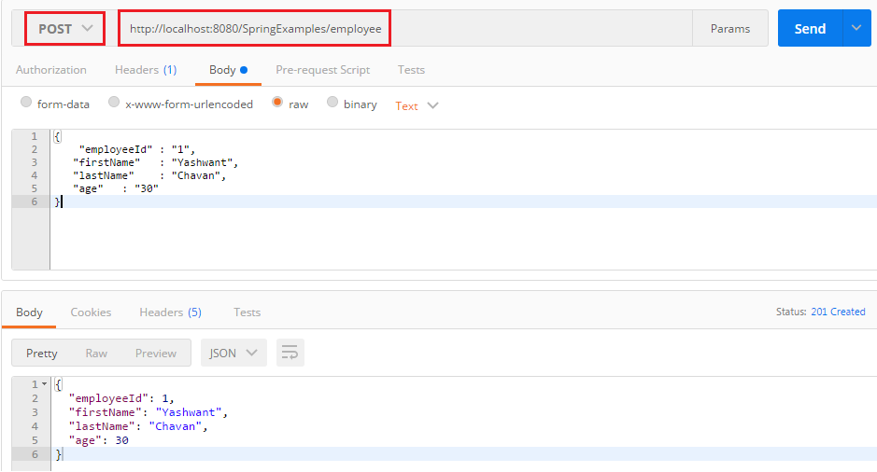

2] Retrieve all employees
- Choose GET to be the selected HTTP method.
- Specify the request URL as http://localhost:8080/SpringExamples/employee
- Add request header value as Content-Type ad application/json
- Click on Send Button.
- It will display all records from the database using Spring rest controller method. Refer below image.
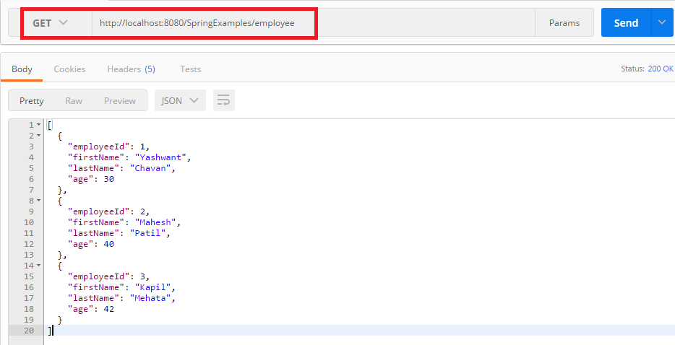

3] Get By Employee Id
- Choose GET to be the selected HTTP method.
- Specify the request URL as http://localhost:8080/SpringExamples/employee/2
- Add request header value as Content-Type as application/json
- Click on Send Button.
- It will return single Employee record whose employeeId is 2. Refer below image.
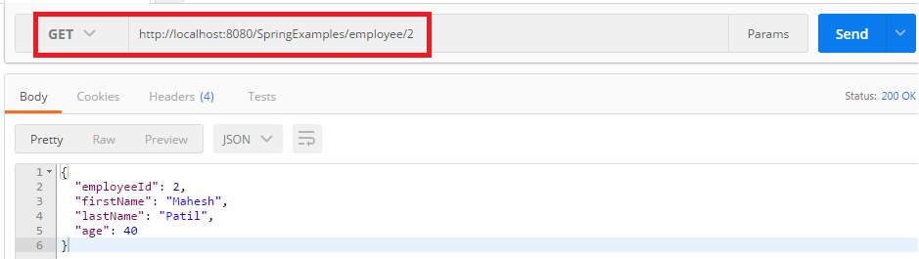

4] Update Employee
- Choose PUT to be the selected HTTP method.
- Specify the request URL as http://localhost:8080/SpringExamples/employee/2
- Add request header value as Content-Type as application/json
- Specify Employee data in JSON format which you want to update.
- Click on Send Button.
- Refer below image and verify the changes in the database.
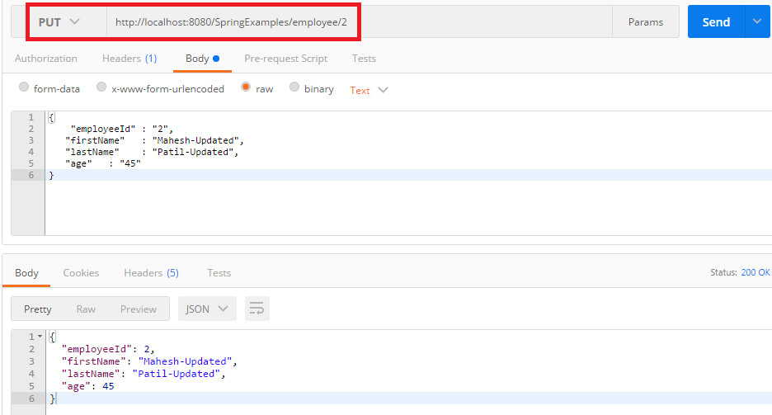

5] Delete Employee
- Choose DELETE to be the selected HTTP method.
- Specify the request URL as http://localhost:8080/SpringExamples/employee/delete/3
- Add request header value as Content-Type as application/json
- Click on Send Button.
- It will delete the record from database.

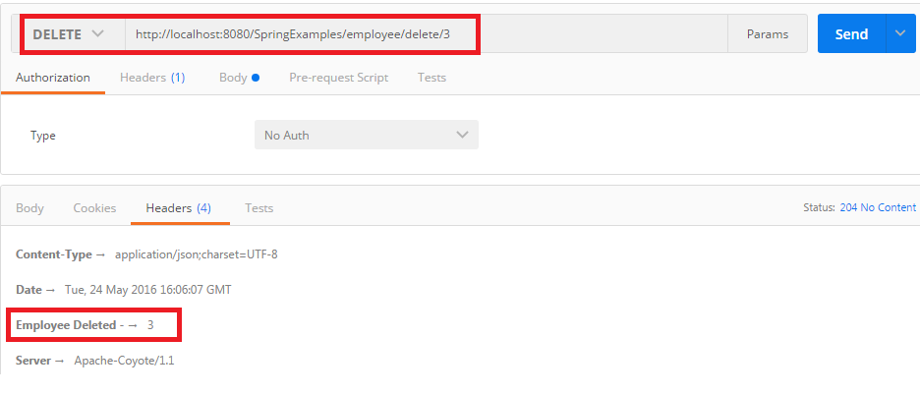

6] Filter Employee
- Choose DELETE to be the selected HTTP method.
- Specify the request URL as http://localhost:8080/SpringExamples/employee/filter/u
- Add request header value as Content-Type as application/json
- Click on Send Button.
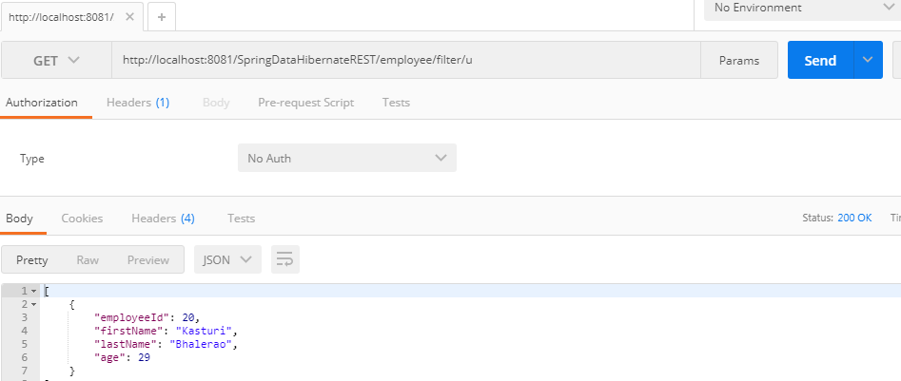

7] Filter Employee
- Choose DELETE to be the selected HTTP method.
- Specify the request URL as http://localhost:8080/SpringExamples/employee/filter/u
- Add request header value as Content-Type as application/json
- Click on Send Button.
